July 15th, 2007
Hi
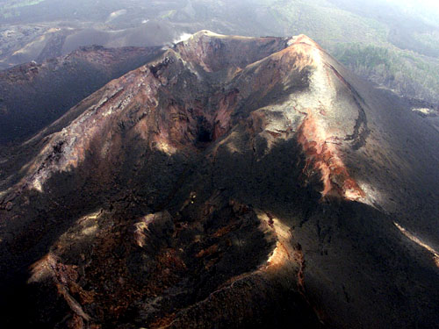
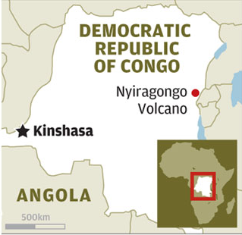
I forgot to mention in last week’s letter of an accident in the (Democratic Republic of) Congo. A Hong Kong tour party, with guides, had climbed to the top of a 3500-metre high active volcano. While taking photographs, a woman fell more than 200 metres onto a ledge into the crater of the volcano. After a day, UN troops arrived and tried to reach her but by then she had died.

Last Sunday, a small Cessna single-engine aircraft made an emergency landing on the Plover Cove Reservoir dam, after it suffered engine problems. Both people on board the escaped injury, and the plane itself was not damaged. The plane was on flying practice over the New Territories when the engine trouble occurred. This is the second time that a plane has landed on this dam.
On Tuesday, I received my new drivers’ license by post from the Transport Department. Very efficient indeed! I remember 10 years ago having to fill out forms and spend a long time in queues in the Shatin office to get the (10-year) licence. This time it could be done on the Internet but only if you have a digital (identity) certificate, which I do not have. Thenout of the blue a letter arrived from the department with an application form already filled out for me to sign and return with a cheque. This I did and the new licence arrived about a week later. I am very impressed with the service. However, I only got a licence for 3 years and not 10 years because of my age. Have to have a health check-up before getting the next licence.
Last Wednesday morning, the hotel did a quarterly cleaning of the suite. Therefore, I went to the CU clinic at that time to get more asthma medicine. Then I called in at the Faculty of Education and had a chat with some people I saw there.

Last Thursday, I was a bit tired but started exercise again, doing just 15 min skipping followed by a 1.2 km swim (in 33/34⁰C water). A little more the following day.
Over the past few weeks, HK has been having very fine weather and the air on many days has been very clear. This is because (relatively) clean air from the South has been blowing across HK. But things will soon return to normal with a northerly wind bringing air pollution from China. Very hot too. Yesterday, temperatures in Sheung Shui reached 36⁰C.
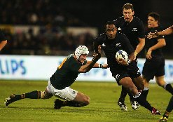
Yesterday, I watched on TV the All Blacks struggle past a SA second-string side to eventually win 33 – 6. All the interesting action was in the last 15 minutes, with the ABs scoring 3 converted tries (21 points) all in the last 11 minutes. The final Tri-nations test is next Saturday between NZ and Australia.
I will not see next week’s test, as I will be in Singapore. I go down on Thursday for just over a week for the re-launch of the revised lower secondary science books. I will give a brief 30-minute talk at the launch (actually, I will give it 3 times to different groups). Later I will conduct a half-day workshop on teaching science.
That seems to be it for now. Will write again in two weeks.

Cheers

